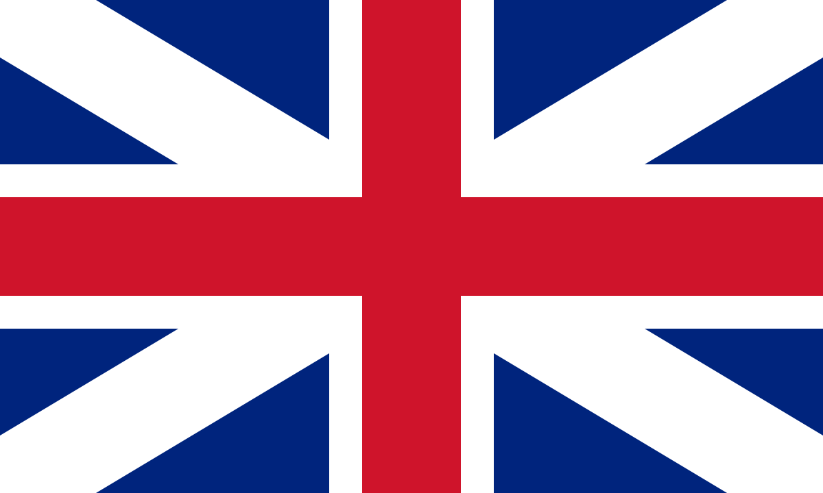

About ICMM

ICMM is the world’s only international maritime museum network, bringing together museums of every size from 36 countries across 6 continents, as well as others involved in maritime heritage.

Founded in 1972, ICMM’s main focus of activities is a biennial Congress hosted by different members around the world (most recently the Baltic, Chile and Hong Kong). In addition, we offer resources on our website; these include policies on maritime archaeology, historic vessels, and maritime curatorship. We also share Member news and items of maritime interest via our monthly e-newsletter and regular posts on our social media platforms.

ICMM is volunteer-run by an Executive Council representing museums from around the world. We also have sub-committees working on various maritime issues, including Maritime Archaeology, Marine Environment and Historic Vessels.

Our most important asset is our Network of over 100 Members worldwide, which provides an unparalleled source of knowledge and contacts for maritime museum professionals. Join us and be connected to others around the world who have a passion for maritime heritage!

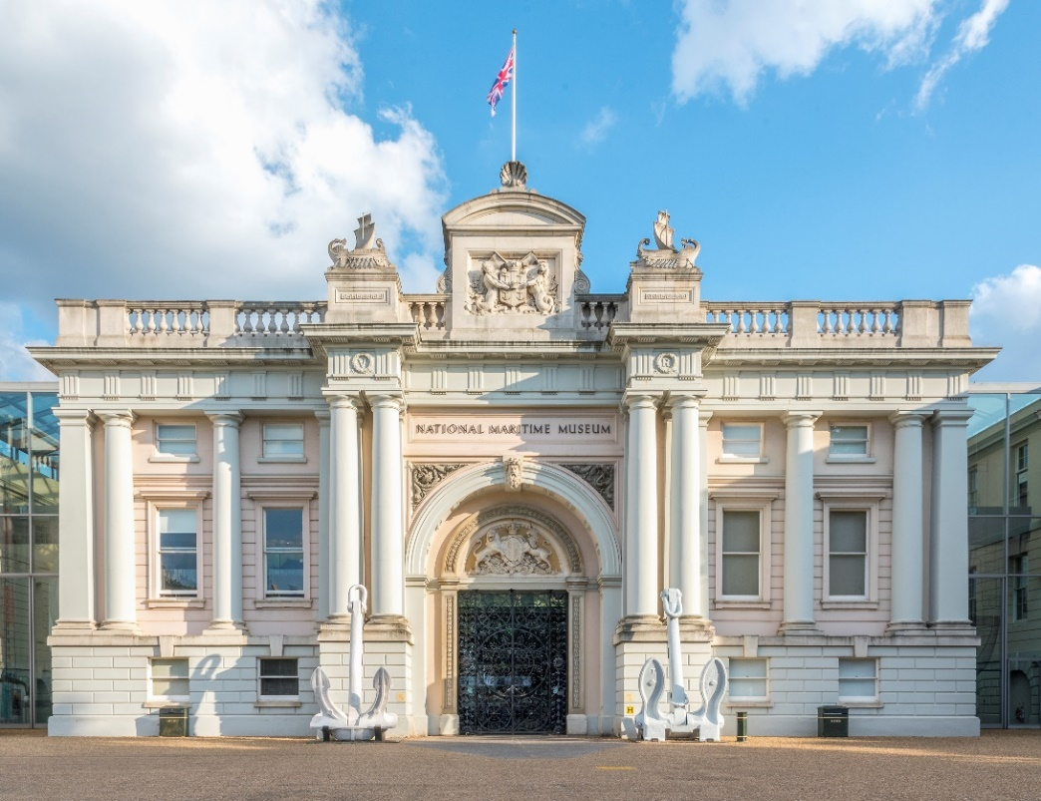

National Maritime Museum, Greenwich, London
About the ICMM Congress

The Congress is held every 2 years in a different location – recently in Chile, Hong Kong, and Stockholm and the Åland Islands. It is typically 5 days long, with 4 full days of talks and discussions, and a day of visiting local maritime heritage sites. Networking is an important aspect of the Congress, with various social events to facilitate this. The atmosphere is informal and friendly, with an emphasis on knowledge sharing and partnership building. The ICMM Richard Foster Bursary scheme assists with attendance of smaller museums and early career professionals.

André Kirouac – Director, Musée Naval de Québec, Canada
“At my first Congress, I found a warm welcome and sense of fellowship; my nerves at meeting the directors of the world’s large maritime museums soon vanished when I realized that we all shared a passion for maritime and naval heritage. I learnt a lot from hearing the experiences of other museums, and in discussing common challenges and novel solutions. For my museum, ICMM has opened the door to partnerships in historical research and exhibitions that have already paid off.”

Why join ICMM?

Read some of our members‘ stories:

Steve White – former President, Mystic Seaport Museum, USA
“I was a relatively new maritime museum director when I attended my first ICMM Congress in 2010. The community welcomed me in, and I have since developed deep professional and personal relationships with my museum colleagues. As a result, three major exhibitions have come to Mystic Seaport Museum, which never would have happened without the ICMM connection.”

Zefeng You – Director, Institute of Ancient Chinese Ships, China
“Over the last seven years, my ICMM connections have been invaluable in enabling me to develop professionally, make friendships all over the world, and to collaborate on several projects with other maritime museums, including a book and exhibition on Chinese collections with a UK maritime museum, and an academic research project in the Netherlands.”

Kristen Greenaway – President, Chesapeake Bay Maritime Museum, USA
“Having previously attended a CAMM (Council of American Maritime Museums) annual conference, attending my first ICMM congress made me recognize that maritime heritage is not just local, regional or national, but truly international. The ICMM community is essential in helping us tell this story.”

Kevin Fewster – Director, Royal Museums Greenwich (2007-2019), including National Maritime Museum, UK
“Having been involved in ICMM since the 1980s whilst leading several different maritime museums in Australia and Britain, I am a lifelong and passionate advocate of the ICMM network. The benefits of ICMM membership, both institutional and professional, are enormous. Moreover, through ICMM I have made many friends for life.”

Please join our network

ICMM has 3 categories of membership:

Full Members
for Museums

Affiliate Members
for Non-Governmental Organisations, research institutes, governmental institutions, and private companies with links to the world of museums and specifically maritime heritage.

Associate Members
for individuals

For Full Members, the fees are on a sliding scale based on a museum’s annual turnover; that way it is fair for everyone, and smaller museums can still enjoy the benefits of ICMM membership.

Details of all fees, and more information on ICMM, can be found on our website:

https://icmm-maritime.org/join/

Any questions?

Email us at: SArcher@rmg.co.uk

© ICMM, 2020 www.icmm-maritime.org

